# Mortgage Questionnaire,

# Improving Transparency and Customers’ happiness

1. Can you please tell me the three first “words” you think of when hearing the word “mortgage”?
2. What are two spontaneous questions which come to your mind when hearing the word “mortgage”?
3. How familiar from 1 (few) to 10 (a lot) are you on the mortgage system in Switzerland?
4. How difficult from 1 (very difficult) to 10 (very easy) do you assess the mortgage topic?
5. Do you currently own a mortgage? In Switzerland?
   1. IF yes, can you remember some pain points in the mortgage subscription process? What went particularly good?
   2. IF no, Have you ever considered apply for a mortgage?
   3. IF no, Could you imagine doing it in the future? Why? Why not?
6. Have you ever looked for information about mortgage online?
   1. IF yes, where and which information?
   2. IF no, would you consider doing it? Why? Or why not?
7. What information on mortgages would you typically look for on the internet?
8. Have you ever used a chatbot (computer-based software assistant) to get information on a product or service?
   1. IF yes, which product/service?
   2. IF no, which communication channel would you consider to get those information?
9. Would you consider using a chatbot to get information on the mortgage ecosystem?
10. Do you have family? What is your profession? How old are you?

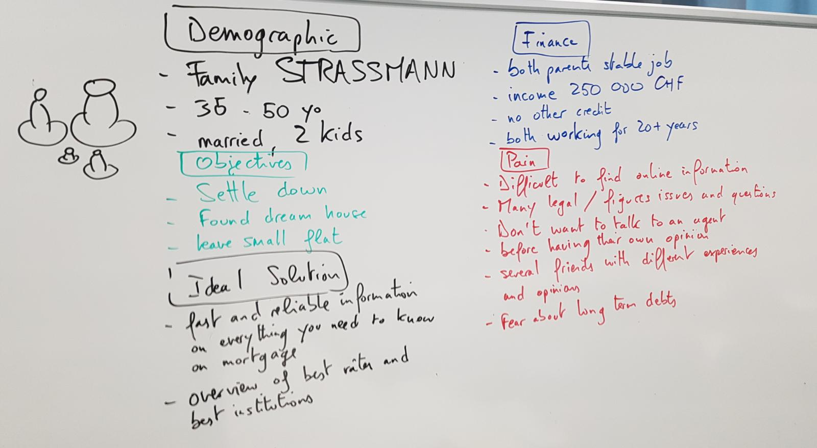

*Persona – Typical Mortgage Prospect*